INTERNATIONAL INDIAN SCHOOL, RIYADH
Ac. Year 2008-2009
IX – XII SECTION
CLASS – XII
SUBJECT – MATHEMATICS
----------------------------------------------------------------------------------------

SECTION A : ( 1 Mark)
- For what value of the following matrix is singular 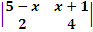
- If A is a square matrix of order 3 such that = 64 find
- If A = 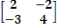 B=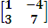 find 2x2
Matrix C such that A+3B−2C = 0.
- Find the inverse of 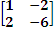
- Solve 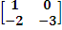 = 0
- If A = 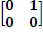 prove that = where I is the Identity matrix of order 2 and n is in +ve integer.
- If A= 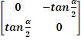 and I is the identity matrix of order 2. Show that I + A = 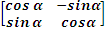
- Express the following matrix as symmetric and skew symmetric matrix 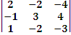
- Using elementary row transformation , find the inverse of 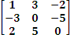
- Using properties of determinant
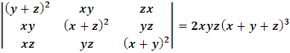
- Using properties of determinant 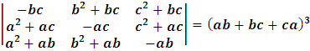
12. If A = 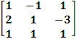 find solve 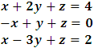
- Solve for 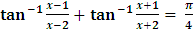
- If - . Prove that 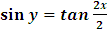
- If . Prove that − 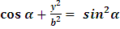
- Find 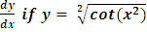
- Find 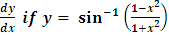
- Find 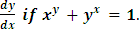
- If . Prove that 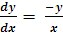
- If 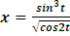 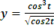 . Find
- If ² . Prove that (
- Verify mean value theorem f(x) =
- If + y =0. Prove that 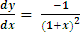
- Find the intervals in which the function f is given
- Prove that curves
- Find the approximate value of
- 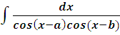 29. 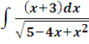
- 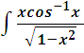 dx 30. 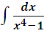
- Using limit as a sum 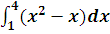
- Using properties of integration 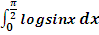
- 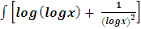 dx
- 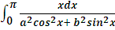
- 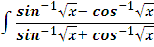 dx
- Find the area of the curves bounded by + =1 and
- A toy manufacturer produces two types of dolls A and B. Each doll of type B takes twice as long to produce doll of type A. The company has time to make a maximum of 2000 dolls of type A per day, the plastic available is sufficient to produce 1500 dolls per day. Type B requires a fancy dress of which only 600 per day are available. If the company makes a profit of Rs 3 and Rs 5 per doll on A and B respectively. How many of each type should be produce per day to maximize the profit.
- An oil company has two depots A and B with capacities of 7000 l and 4000l respectively. The company is to supply oil to three petrol pumps D,E,F whose requirements are 4500l, 3000l, and 3500l respectively. The distance between the depots and petrol pumps is given in the following table.
From/to | Distance in K/M  A B
D | 7 | 3
E | 6 | 4
F | 3 | 2

Assuming that the transportation cost of 10 litres of oil is Rs 1/ per kilometer , how should the delivery be schedule in order that the transport cost s minimum ? What is the minimum cost.

- In a hurdle race, a player has cross 10 hurdles. The probability that he will clear each hurdle is . What is the probability that he will knock down fewer than 2 hurdles.
- In a hurdle race, a player has cross 10 hurdles. The probability that he will knock down fewer than 2 hurdles.
- Solve
- Form the differential equation representing the family of ellipses having foci on axis and centre of origin.
- Solve } }
- A problem in mathematics is given to three students whose chances of solving it are , and respectively . If all the three try to solve the problem simultaneously find the probability that exactly one of them . Can solve it.
- Find the degree and order of the differential equation. 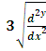 =
- The probability that an event happens in one trial of an experiment is 0.4. Three independent trials of the experiment are performed. Find the probability that the event happens at least once.
- Find the equation of the plane passing through the interaction of the planes and perpendicular to the plane Also find the inclination of this plane with plane.
- What is the angle between and with magnitude and 2 respectively. Given .=3
- Write the value of i. (j x k ) + j.( k x i )+k.( j x i ) = 2
- If and are unit vectors and is the angle between them. Then prove that 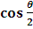 =
- If = i and .Find a unit vector perpendicular to
x
- Prove that the image of the point (32 in the plane lies on the plane
- Find the foot of the perpendicular from the point P(1, 2, 3) on the line 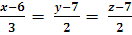 . Also obtain the equation the plane containing the line and the point (1, 2, 3)
- Cartesian equation of a line AB are 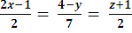 . Write the direction ratios of a line parallel to AB.
- Find the shortest distance between the lines whose equations are 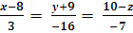 and 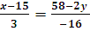 =
- Find the equation of the of the plane passing through the points ( 3, 4, 2) and (7, 0, 6) and is perpendicular to the plane
- Find the value of such that + is perpendicular i where = i + 2j +3k and = −i + 2j +k and = 3i + j
- Let = i − j and and = , which is perpendicular to both and and , = 1

Prepared By, Mrs. Chitra .J. , IX – XII Boys

