INTERNATIONAL INDIAN SCHOOL, RIYADH
VI – VIII SECTION

CLASS : VIII

MATHEMATICS

EXPONENTS (Powers)

1. Simplify and write in exponential form:
a. Х b. Х

cХ Х dХ
e. Х Х f. Х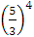
g. Х h.
2. Find the value of:
a. 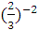 b. 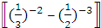 ( c. 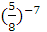Х 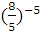 d. + Х e. ( Х ) f. ( + 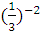 +(
g. h. 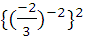 i. 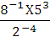 j. (Х) Х k. l. (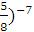 Х 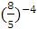
m. 25 Х n. Х Х 125
Х10Х Х
3. Evaluate :
- b. ( c. d. 1/ 3 ⁻² e.
4. Find the multiplicative inverse of the following :
a b. c . d. e.
5. If =(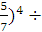 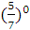 Find the value of if m=3 n=4
6. Find the value of if x= (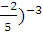 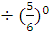
7. What should be divided so that the quotient becomes 9?
- What should 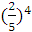 be multiplied so that product becomes 25?
- Express each of the following rational number in exponential form:
- b. c. d. 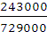
- Simplify and express the result as powers of 2:
- b. + ) ( +)
- Express the following as a rational number:
- 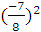 ii.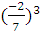 iii.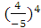
Type equation here.iv. 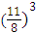 v. 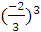 vi. 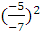

- Express the following as a rational numbers in power notation:
i. ii. iii. 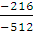 iv.

v. vi. 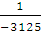 vii. viii.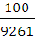
13. Simplify:

i. [-1/3-(7/5)²] Х (3/5)² ii. (-3/8)³ Х 4³ Х (2/3)²

iii. [(4/5)² +(5/-7)²] Х (2/5)² (-4/5)³
iv.(-3/8)² Х (5/6)³ [ 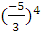 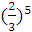] (4/9)²
14. Find the reciprocal of:
i) (-7/3)² ii) iii) (-6)³ iv) (2/-3)³ × (3/-4)² v) (2/3)² × (3/4)²

5. Find the absolute value of :

i)(2/3)³ ii) (-4/7)² iii) ((5/-8)³ iv) (-11/13)²

6. Which of the two rational numbers (-3/5) and (3/5) is smaller? Insert four rational numbers between them.

7. Find the product of the cube of (-2/3) and the square of (4/-5).

8. Fill in the blanks:
i) = (-2)⁻⁻⁻⁻⁻ ii) =(1/-3)____ iii) (4²)³ = (4)_________ iv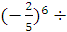 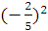 = (-) ______
v) 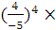 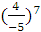 =(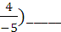 vi) = (-6)______ 9. Simplify:

i) (3/4)² × (3/4)³ ii) (-2/7)² × (-2/7)³

iii) ÷ (-7/8)² iv)(1/3²)³

10. Simplify and express the result in power notation:
i) ( ii) (
iii) (-5/2)³ ÷ iv)[(-3/4)²]³

v) (-5/7)⁶ ÷ (-5/7)³ vi) [(-3/4)²]³

vii) [(-5/7)⁴]⁵

11. Find the value of:
i) ii) ( iii. (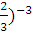

iv) (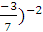 v) 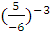 vi)

- Express the following as a rational number with positive exponent by using laws of exponents:

i) ii)( iii) iv) v) ( vi) Х

- Express the following as a rational number with negative exponent by using laws of exponents:

i) ii) iii) Х iv) 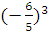 1/-6 v)

14.Find the value of :
i) 5° ii) 2° + 4° + 5° iii) 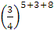
iv) v) (2° Х 4° 5° + 3°) 7°

15. By what number should we multiply so that the product may be equal to 25 ?

16. By what number should be divided so that the quotient may be equal to ?

17. Find the value of x, such that Х = .

18. Find the value of y, such that Х =

19. Find the reciprocal of the rational number :

[( Х (6/7)² ] [(3/7)² Х
20. If x= Х (3/4)², find
21. If y= (5/2)² Х (, then find the value of y³.

VI – VIII GIRLS, IISR

--------------------------------------------------------------------------------------------

