UNIT – 11 – SAVED BY A DOLPHIN &
WORKSHEET - 11
Word Meanings :
overboard -
plotting -
spare my life -
astonished -
confessed -
crime -
charmed -
Make meaningful sentences :
- plottting -
- astonished-
- confessed -
- crime -

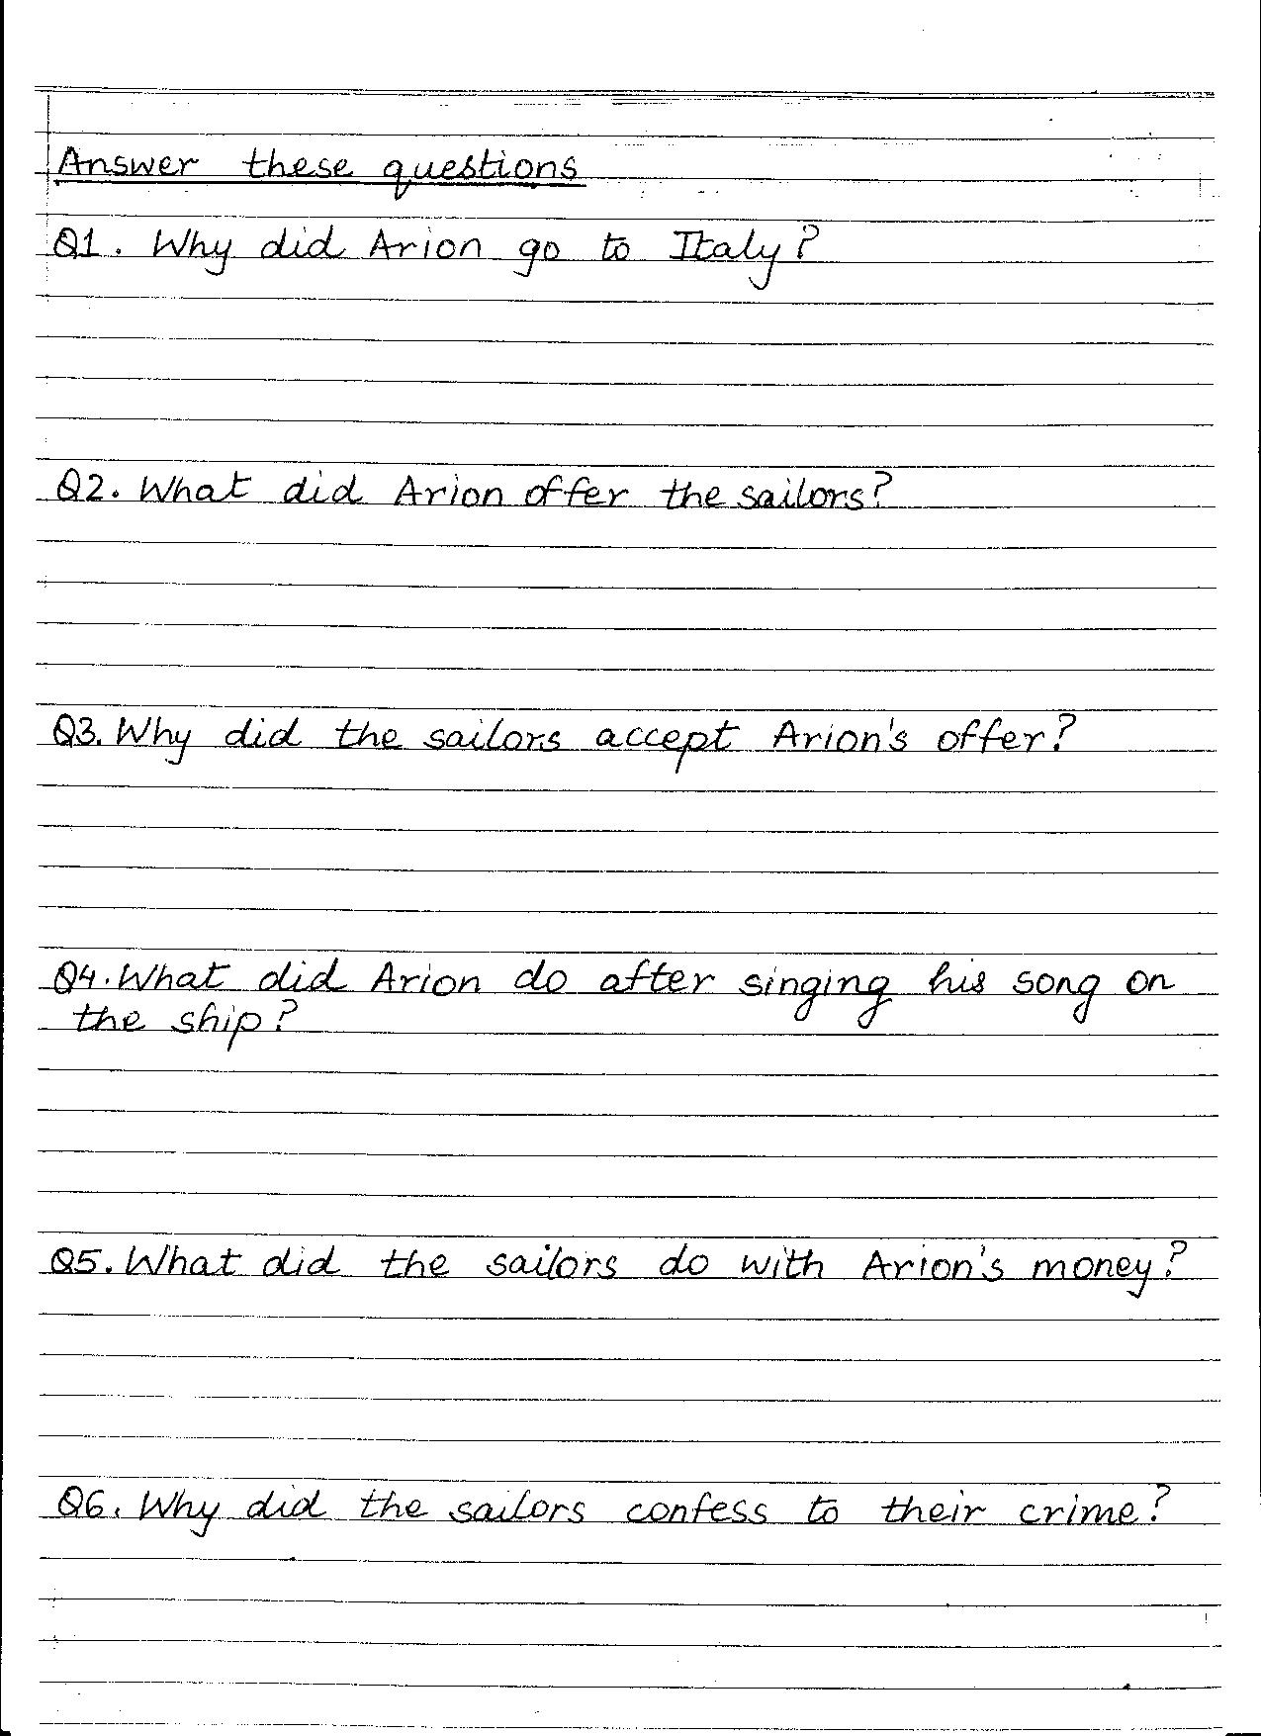
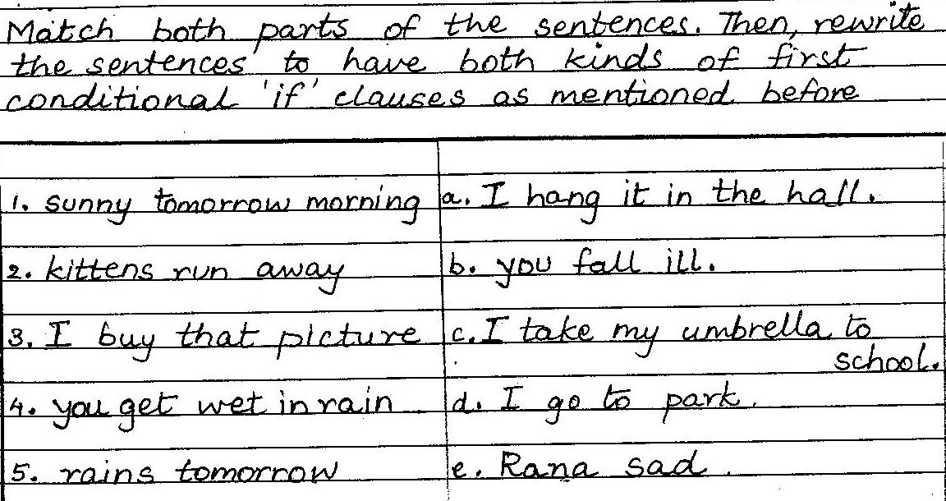

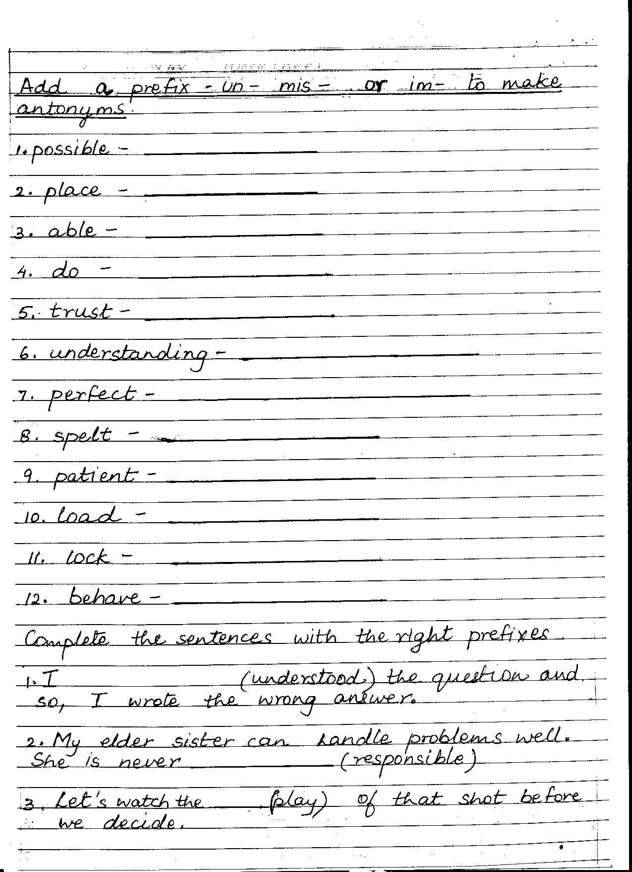
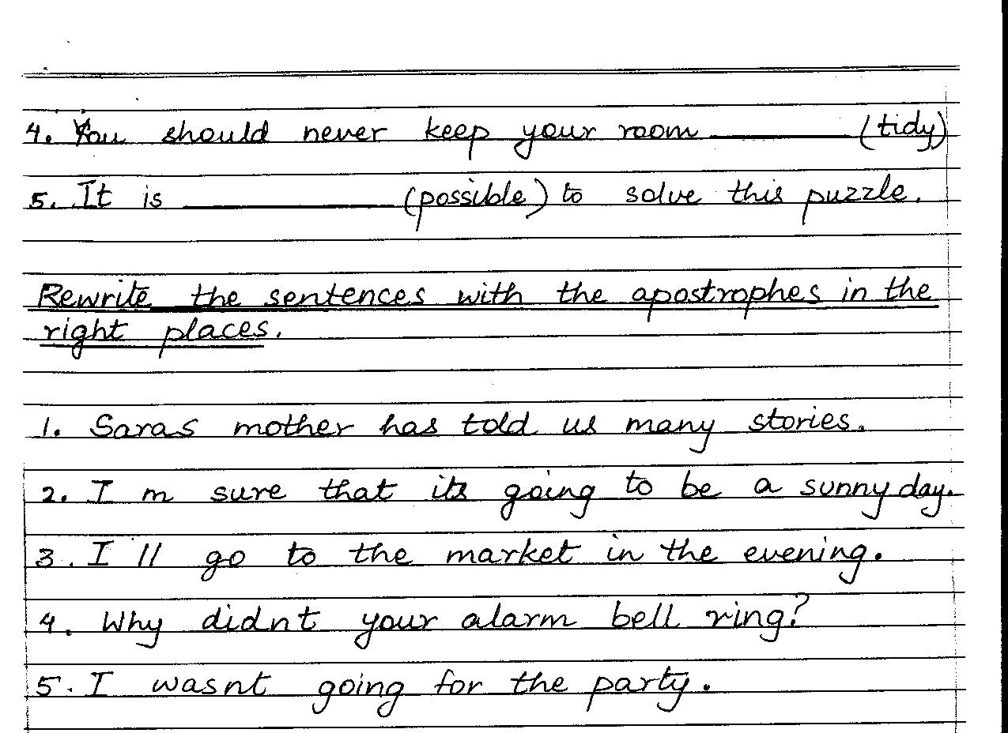
-IISR GIRLS

