INTERNATIONAL INDIAN SCHOOL, RIYADH
CLASS – V, SA-2, 2013-2014
Writing Tasks :
- Write a letter to your friend describing how you celebrated a festival.

Writing Tasks :
- Write a letter to your friend describing how you celebrated your birthday.

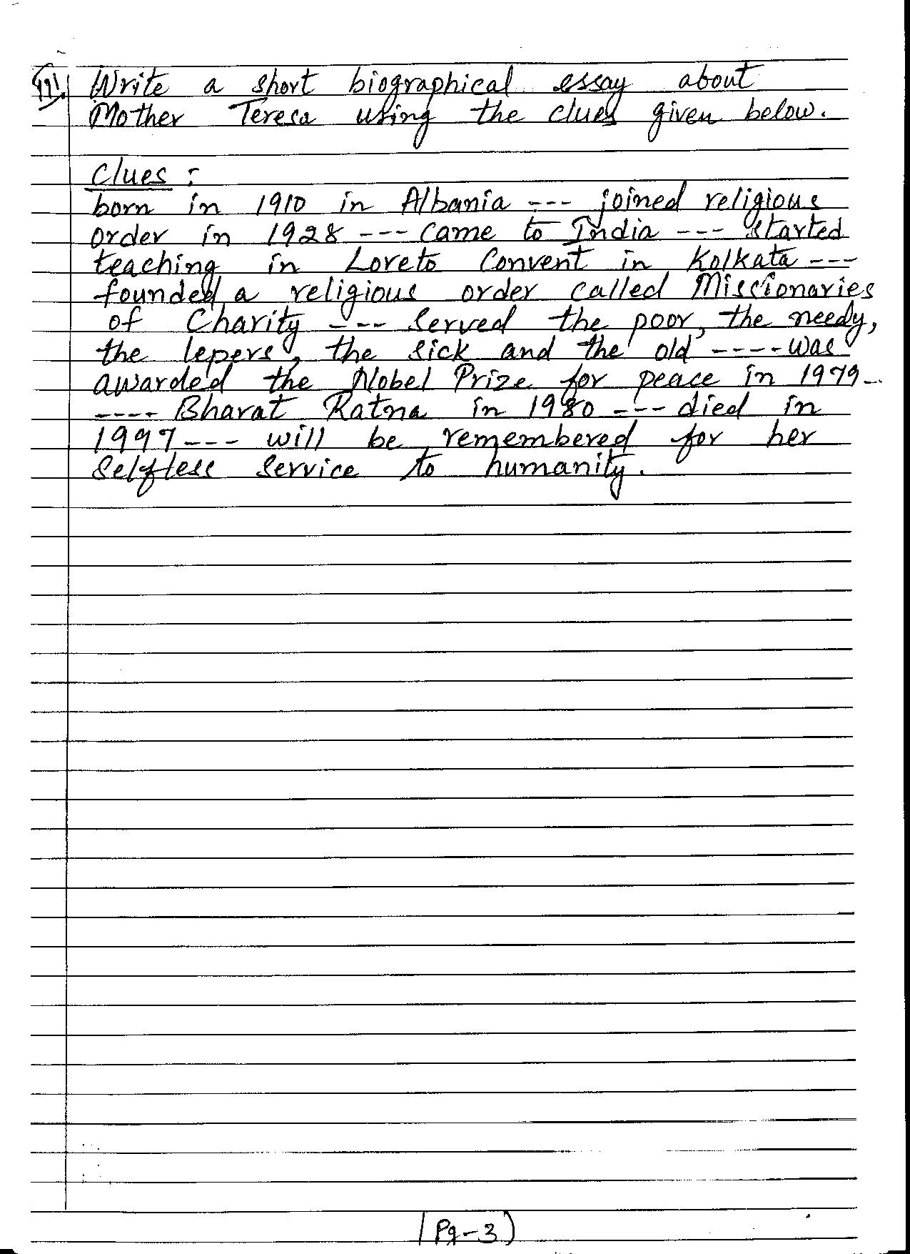

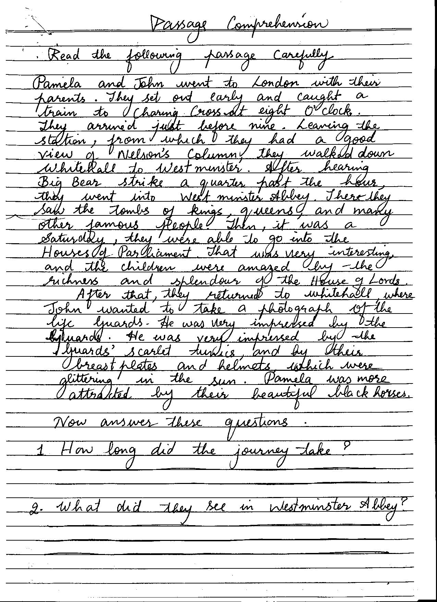
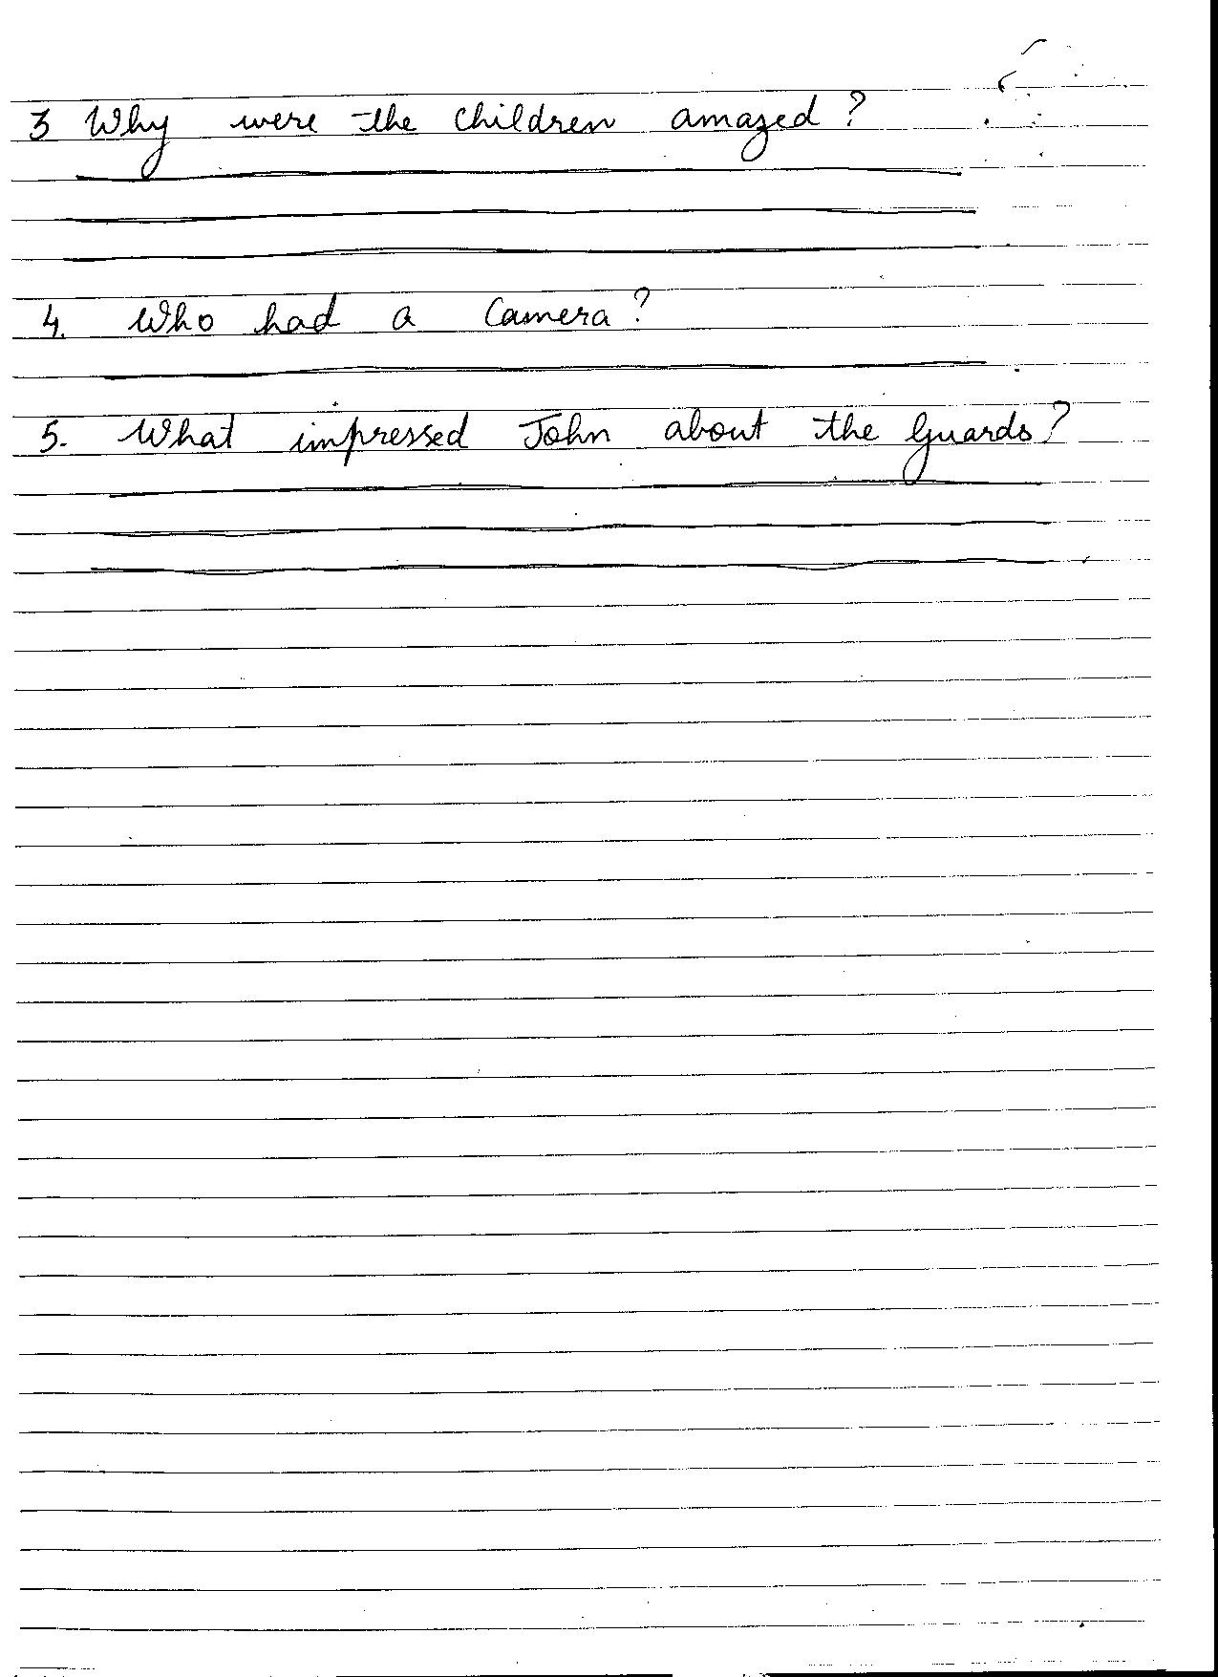
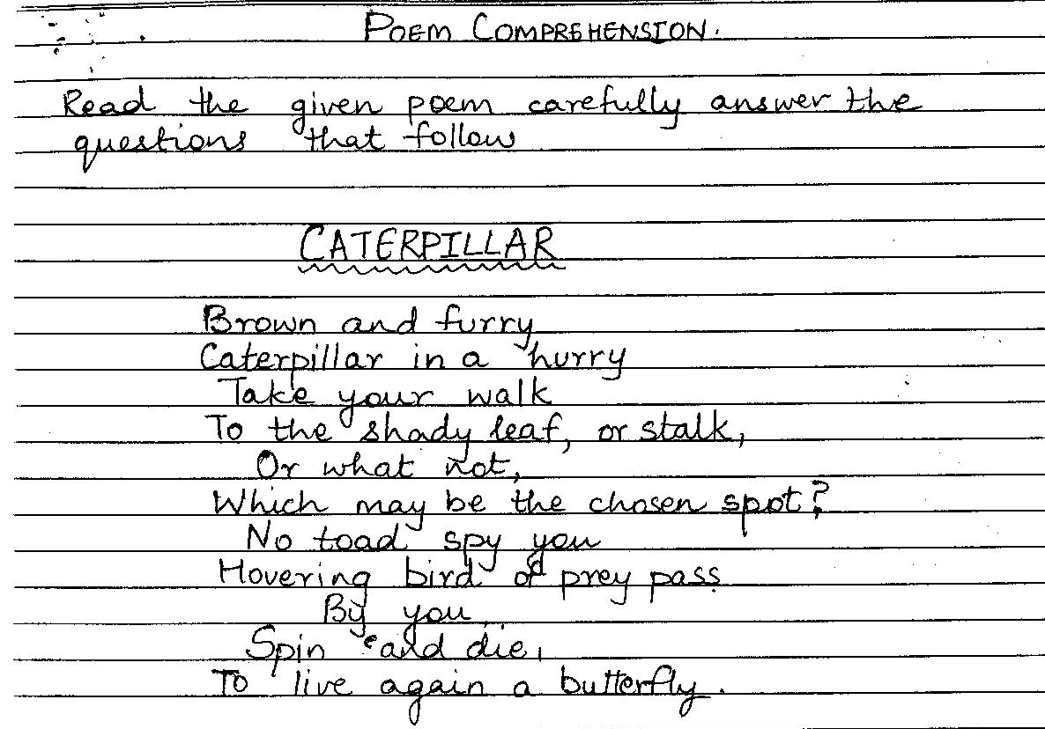
Answer the following questions :
- How does the caterpillar look ?
__________________________________________________________________
- Where does it live ?
______________________________________________________________________________________________________________________________________________
- What does the caterpillar become ?
______________________________________________________________________________________________________________________________________________
- Complete the following sentences :

The caterpillar chooses a spot where ________________________ birds and _________________ can’t see it. It spins and _____________ and_______________ again as a butterfly.
- Give opposites of the following words from the poem :
- live - ____________________
- delay - __________________
- shady -__________________
- walk - ___________________

