I. Write a composition on “My Best Friend”.

International Indian School, Riyadh.
First Term Revision Work Sheet- 2013-2014.
Class-I – ENGLISH (course book)
Prepared By: Mrs. Adeeb Kehkashan.
I & II Boys School
1._______________________________________________________________
_______________________________________________________________
2._______________________________________________________________
_______________________________________________________________
3._______________________________________________________________
_______________________________________________________________
4._______________________________________________________________
_______________________________________________________________
5._______________________________________________________________
II.Fill in the blanks:

1} The peacock has a _______________tail.
2} The rabbit has a ___________ tail.
3} The monkey has a _________ tail.
4} The horse has a ___________ tail.
5} Little Grey Cat has ____________ tail.

III. Answer the following questions:
Q1} Why is the little Grey cat sad?
Ans: ____________________________________________________________
_____________________________________________________________
Q2} Who has a lovely tail?
Ans: ____________________________________________________________
Q3} What does Rohan want to play ?
Ans: ____________________________________________________________
_____________________________________________________________
Q4} Why it is hot in summer ?
Ans: ____________________________________________________________
______________________________________________________________
Q5} Where can we play when it is very hot?
Ans: ____________________________________________________________
_____________________________________________________________
6} Write three ways to keep your body cool in summer
Ans:1. ____________________________________________________________
2. _____________________________________________________________
3._____________________________________________________________
IV. Tick (√) for the correct sentence and (×) for the wrong sentence:
1} Little Grey Cat does not like his tail. So he wants a new one. [ ]
2} The cats see a rabbit with a small,white tail. [ ]
3} The bird has a big tail. [ ]
4} The monkey swings on the tree. [ ]

V. Name the following:
1} Name two games you play indoors.
Ans 1._______________________
2._______________________
2} Name two games you play outdoors.
Ans 1._______________________
2._______________________
3} Name two fruits you get in the summer.
Ans 1._______________________
2._______________________
VI. Re-arrange these words and write complete sentences:
1} in summer. / hot / It / is
Ans: _________________________________________________.
2} She / eating / ice-cream. / is / an
Ans: _________________________________________________.
3} mangoes / These / sweet. / are
Ans: _________________________________________________.
4} am / I / swimming.
Ans: _________________________________________________.
VII. Complete the colour words & fill the boxes with the colour:
1} r __ d 4} b l__ __ 7} gr __ y
2} br __ wn 5} gr __ __ n 8} wh __ t __
3} y __ ll __ w 6} bl __ ck 9} __ r __ n g __
VIII. Write the opposites for the following.
1. same X _______________. 6. old X _____________.
2. long X _______________ . 7. clean X _____________.
3. black X ________________. 8. empty X _____________.
4. hot X ________________. 9. fat X ______________.
5.happy X ________________. 10. boy X ______________.
IX.Comprehension.
A) Tigers.
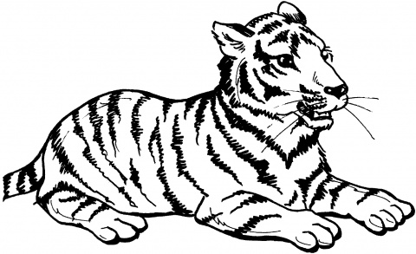
Tigers are big cats. They live in forests. They live in forests. They have
orange Skin. There are black stripes on it .Tigers have sharp teeth . They
eat large animals like deer. Sometimes they eat monkeys, birds , frogs
and fish. Tigers like water. They swim well . They sit in water to keep
cool. Baby tigers are called cubs.

Circle the right answer.
1.Tigers are _____ . {big/small}
2.Their skin is ______________. {yellow/orange}
3.There are _______________on their skin. {dots/stripes}
4.Tigers eat ________________. {animals/leaves}
5.Their babies are called_____________. {cubs/pups}

B. Nitu’s Paper Boats
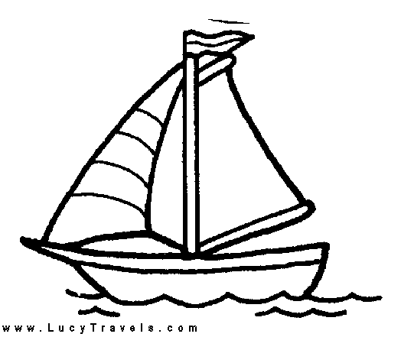
The sky is dark. It is raining. Nitu is sitting with her mother.They are
making paper boats.Look! It ha stopped raining . The sun is shining.
There is a pool of water in the garden. Nitu’s boats are in the pool.They
go round and round. “Look up there,”says Nitu’s . mother.There is a
rainbow in the sky.The rainbow has many colours!

Write the answers in the boxes.

1.Whos is sitting with Nitu ?

2.What are they making ?

3.Where is Nitu’s boat?

4.What is in the sky ?

- NOUN
International Indian School, Riyadh.
First Term Revision Work Sheet- 2013-2014.
Class-I English (Grammar)
Prepared By: Mrs. Adeeb Kehkashan.
I & II Boys School
I. Define a Noun or What is a noun?
Ans : ______________________________________________________
___________________________________________________________
___________________________________________________________
II. Underline the nouns in the following sentences:
1} That is my book.
2} The girls are singing.
3} I like to eat burger.
4} The woman is sleeping.
5} His shoes are dirty.
6} A horse runs fast.
7} The boys are fighting.
8} Tom is very tall.
9} We went to the beach.
10} Zara is playing.
11}Honey is sweet.
12}The moon shines at night.
13}The cat is sleeping.
14}My bag is new.
15}I live in Riyadh
III.Choose the correct nouns from the box and write them in the correct column:
Rita hospital rabbit India bottle man bag teacher ice-cream horse park school book sister monkey
PERSONS PLACES
1} --------------------- 1} --------------------
2} ------------------- 2} --------------------
3} --------------------- 3} --------------------
4} ------------------- 4} --------------------
ANIMAL THINGS
1} --------------------- 1} --------------------
2} ------------------- 2} --------------------
3} --------------------- 3} --------------------
4} ------------------- 4} --------------------
{ Practise with different sentences}

2.ADJECTIVE
I. Define an Adjective or What is an adjective ?
Ans : ________________________________________________________________
____________________________________________________________________
____________________________________________________________________
II. Fill in the blanks with the words given in the box:
hot small wet long pretty new fast lovely funny loose dry

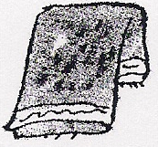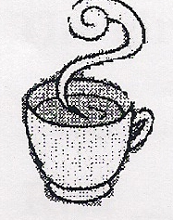
1} __ ______ towel 2}_ _____ milk
3}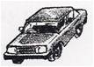_______ car 4}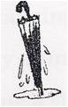____ umbrella 5}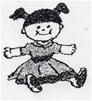_________ doll 6} a 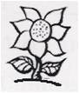_________ flower
7} a _____ball 8}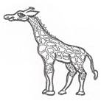_______ legs 9}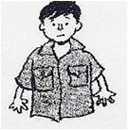_____ shirt 10} a 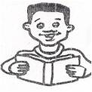_______ story
11} a 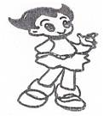_______ girl

3.PLURALS
I . Write the plurals of the following.
1} fish__________ 11} fruit __________
2} church _________ 12} bench __________
3} potato __________ 13} mango _________
4} book __________ 14} bottle __________
5} boy__________ 15} torch __________
6} tax __________ 16} fox __________
7} star __________ 17} ring __________
8} key __________ 18} glass __________
9} watch __________ 19} book __________
10} boy __________ 20} bus ________
(NOTE: Learn more ‘s’ & ‘es’ words only)
4. Use of am , is & are
I.Fill in the blanks with am, is or are .
1} The sun ------------ shining.
2} The boys ---------- playing football.
3} These books _______________ mine
4} Anoop _________________my best friend
5} He _____________ a doctor.
6} It _______________ raining.
7} I_____________doing my work.
8} Arun and Ann __________________readily.
9} The girls _______________ dancing
10} I __________ seven years old.
11} There __________ many birds flying in the sky.
12} Meena ___________cooking in the kitchen.
13} Children _______________writing a story.
14} These flowers __________very beautiful.
15} Anoop _____________ my best friend.
{ Practise with different sentences}

I________ at the park. There ________ flowers in the grass. There ________ a slide. We _______ playing on the slide. A man ________ flying a kite. A little boy ________ watching him. There ________ two clouds in the sky. Two boys ________ playing football.
II. Look at the picture and describe the things that you see using am, is and are:
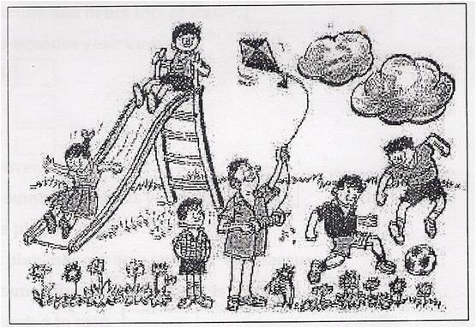
III. Complete the sentences using “There is” or “There are”:
1} ------------ -------------- a watermelon in the basket.
2} ------------ ------------ five mangoes in the box.
3} ---------- ------------- a sharpener in her bag.
4} ----------- ------------- a pencil – box in Maria’s bag.
5} ---------- -------------- five colour pencils in her bag..
6} --------- ----------- an eraser in her pencil- box.
7} ----------- ----------- many boys in the class.
8} ---------- ---------- a pencil in your bag.
9} ---------- ------------- a plate on the kitchen.
10} ------------ -------------- ducks in the water.
11} ______ _____________ trees outside the house.
12} _____________ ___________ a sun in the sky.
13} __________ __________is a man sitting on the chair.
14}___________ ______________ boys playing with a ball.
15}___________ _____________ a bird on the tree.
{ Practise with different sentences}

PUNCTUATION ( Fullstop & Capital letter )
- Rewrite the following sentences using capital letters and fullstop where ever necessary.
- the baby is sleeping
A _______________________________________
- riyadh is a big city
A_______________________________________
- birds are flying in the sky
A.______________________________________
- ravi is a good boy
A____________________________________
5.india is our county
A______________________________________
6.raniya is playing with a doll
A_______________________________________
7.amit is sitting on a chair
A_______________________________________
8.john has a new bike
A_______________________________________

{ Practise with different sentences}

