INTERNATIONAL INDIAN SCHOOL, RIYADH
WORKSHEET –SA1 (2013-2014)
STD. VIII
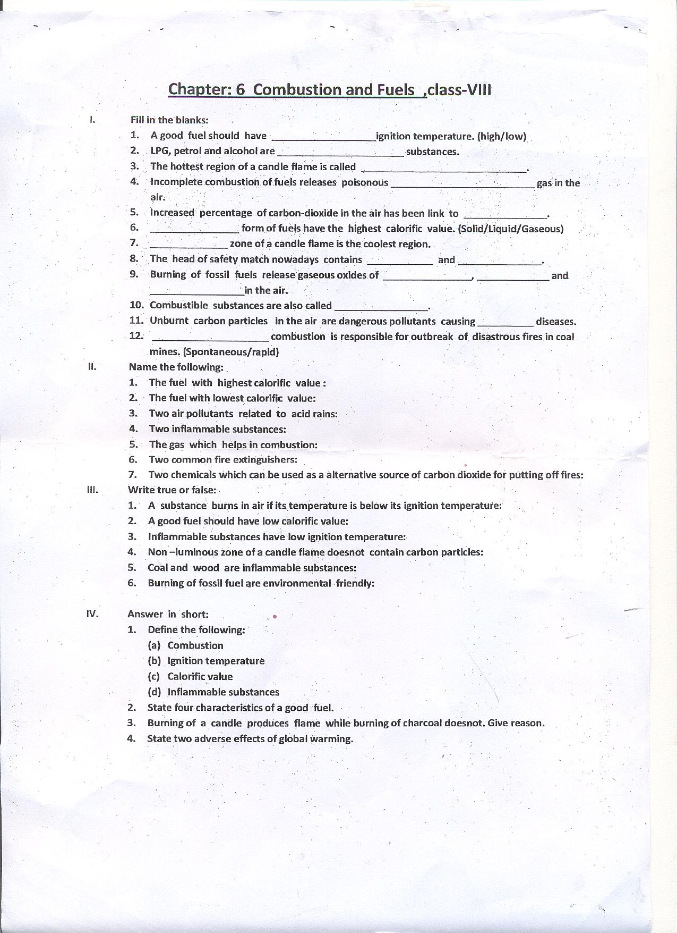
SCIENCE
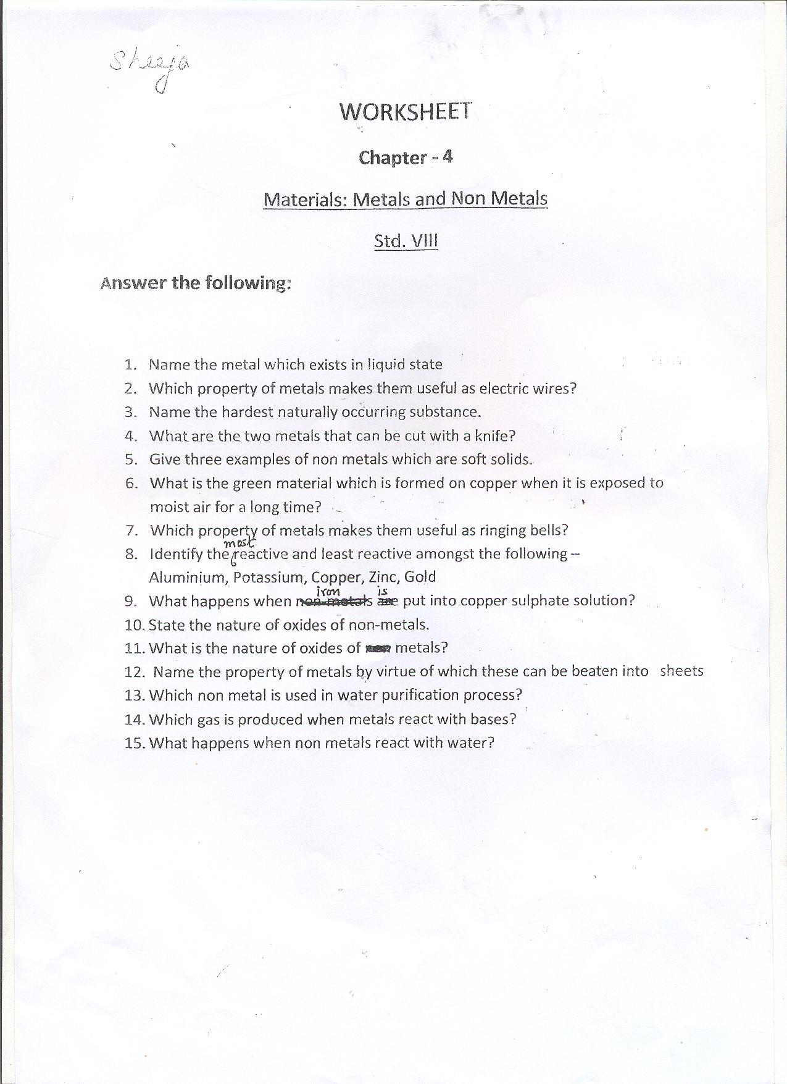
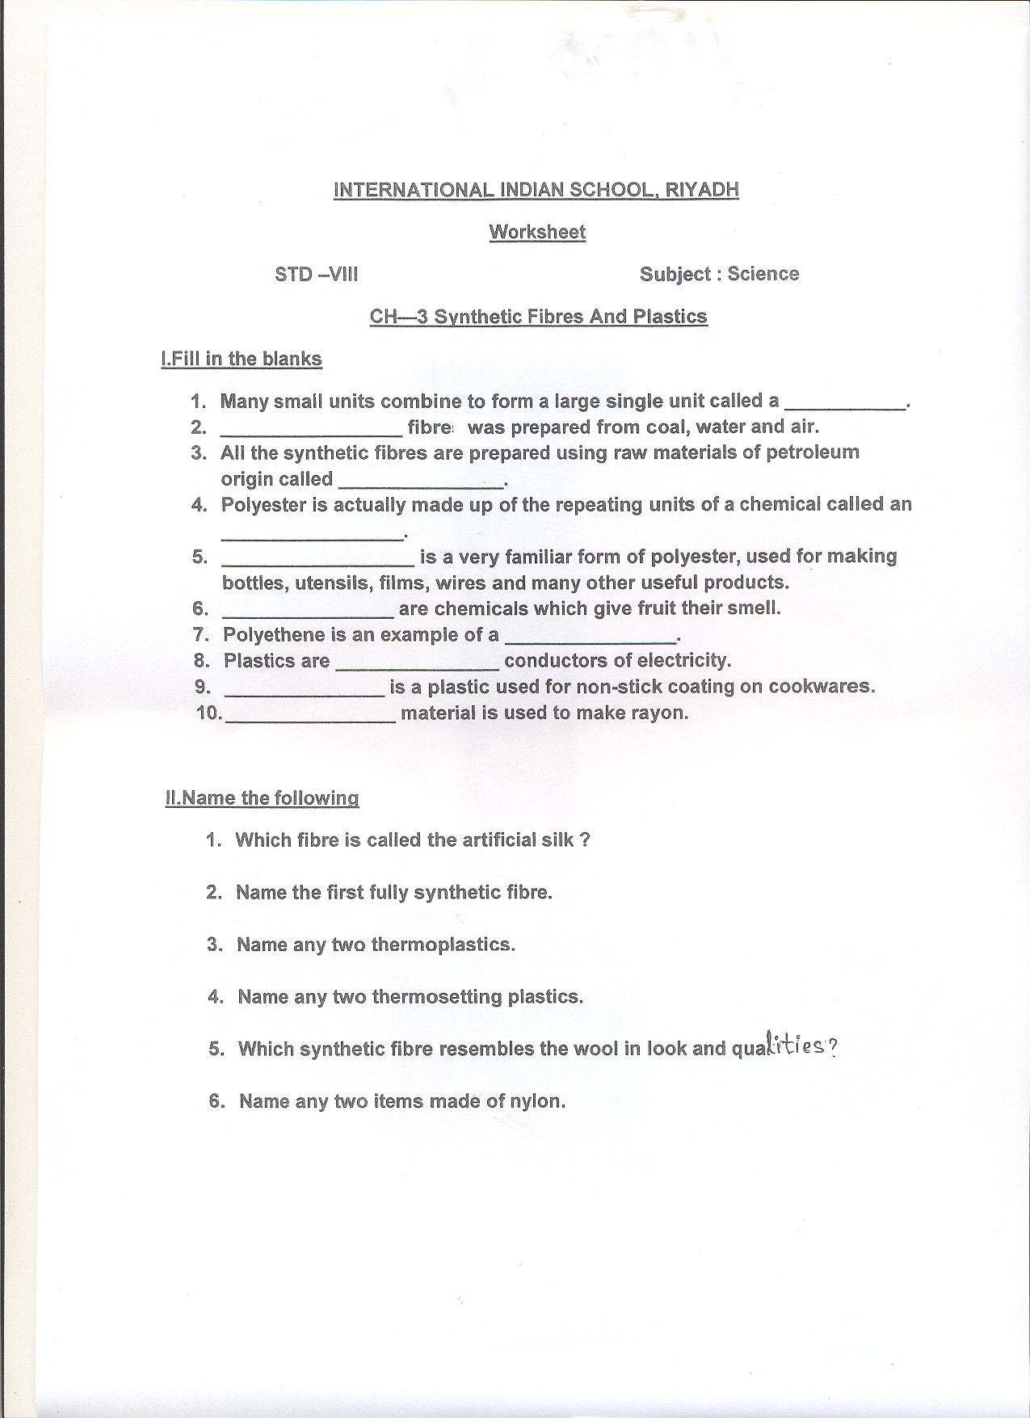

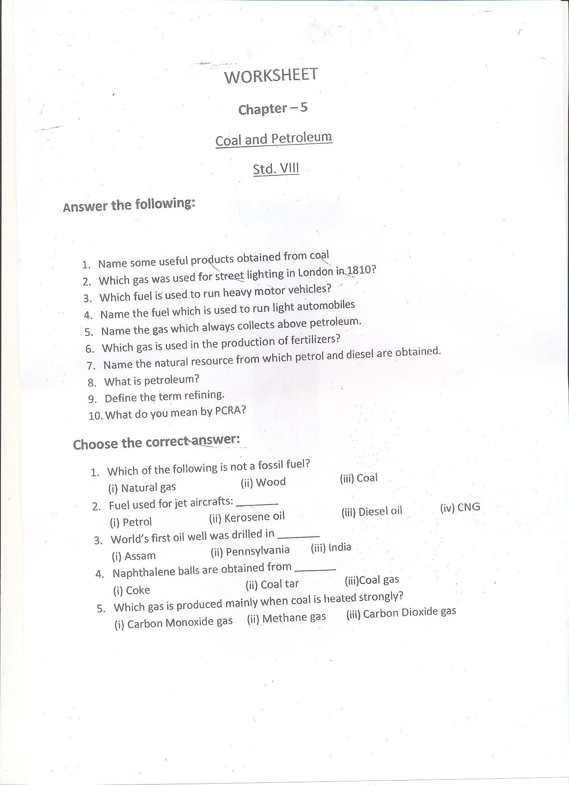
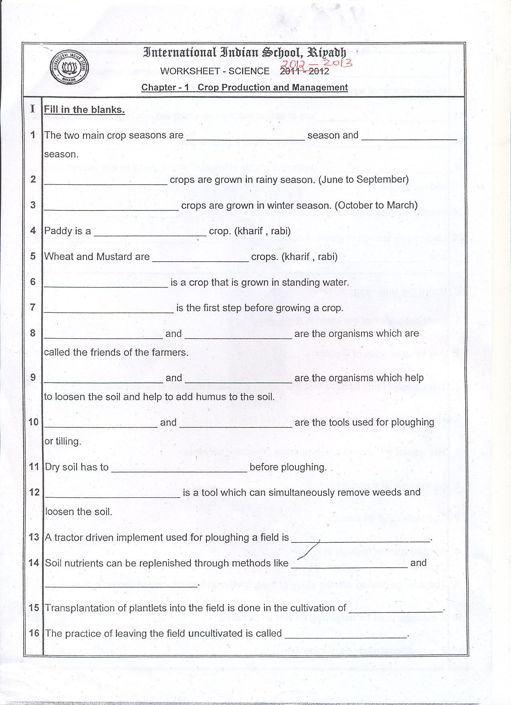
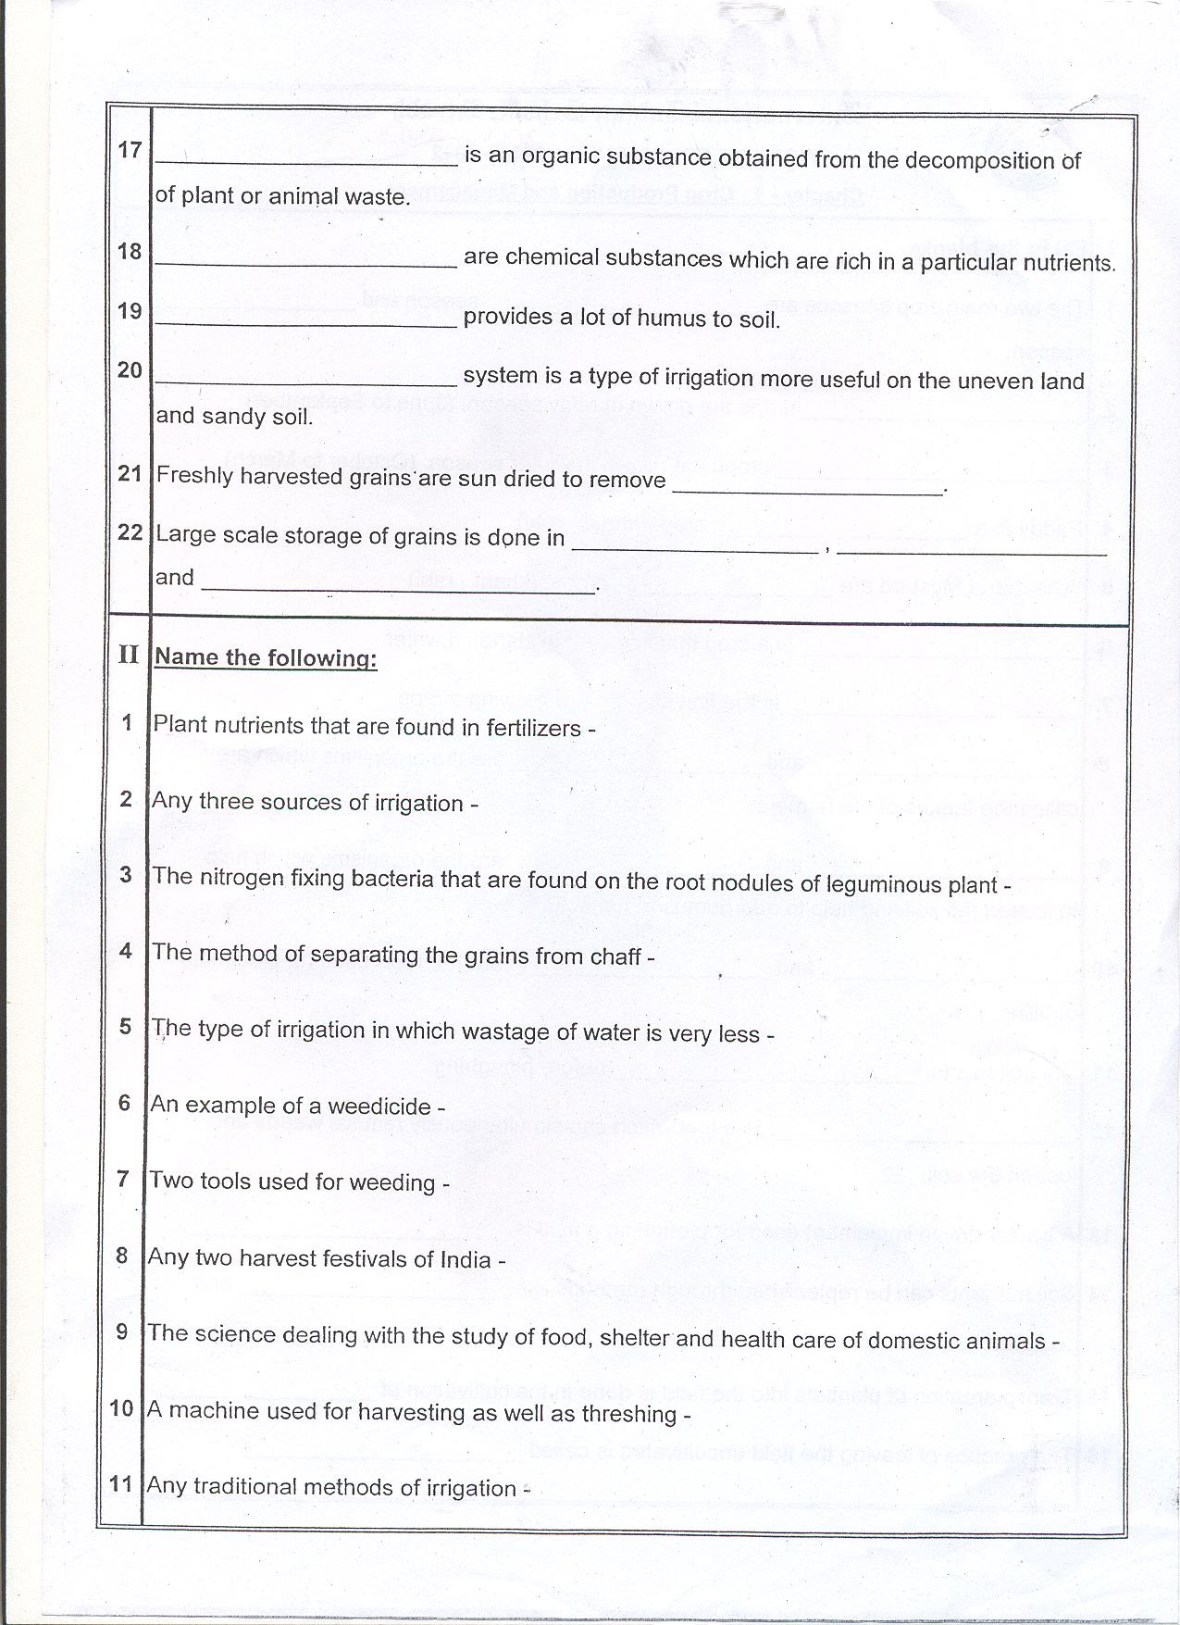
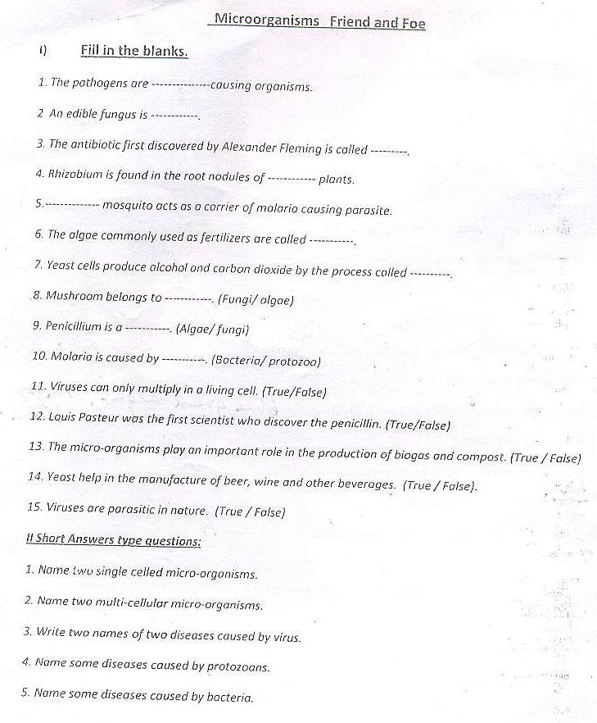
6. Name two groups of micro-organisms live in colonies.
7. Name the micro-organism which promote the formation of curd.
8.What is fermentation?
9.Name the scientist who discovered the fermentation?
10.Who discovered the antibiotics ?
11. Name some antibiotic.
12.Name two communicable diseases.
13.Name the most popular vaccination programme.
14.Who discovered the vaccine for small pox.
15. Name two communicable diseases.
16.Name some preservatives.
17.Which microorganisms are called nitrogen fixing bacteria.
18.What are preservative?
19.Where does Rhizobium bacteria commonly live?
20.Name the carrier of dengue fever.
21.. Mention the amount of nitrogen gas in atmosphere ?

