INTERNATIONAL INDIAN SCHOOL, RIYADH
FINAL TERM WORKSHEET - 1
2012
2013
CLASS II - MATHEMATICS

CHAPTER 7. DIVISION

I) Divide the following :

1. | 12 6 = | 11. | 18 2 =
2. | 16 4 = | 12. | 40 8 =
3. | 36 9 = | 13. | 35 5 =
4. | 21 3 = | 14. | 30 6 =
5. | 20 10 = | 15. | 72 8 =
6. | 42 7 = | 16. | 24 8 =
7. | 48 8 = | 17. | 40 5 =
8. | 32 4 = | 18. | 36 6 =
9. | 72 9 = | 19. | 54 9 =
10. | 56 8 = | 20. | 64 8 =

II)Encircle groups of 2. Complete the division sentences :-
1.

2.


III)Encircle groups of 5. Complete the division sentences :-
1.


2.

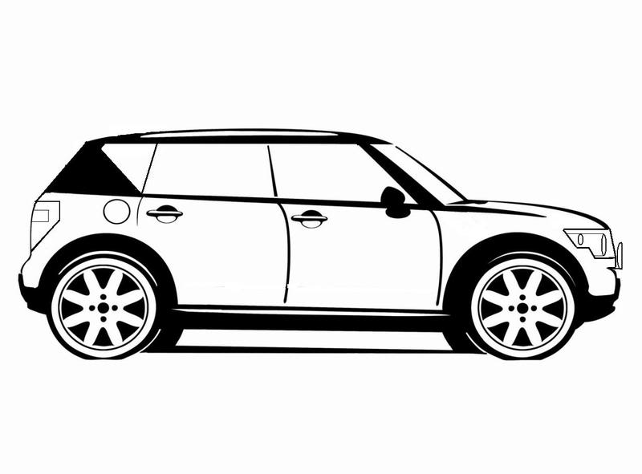
3.

IV)Encircle groups of 3. Complete the division sentences :-


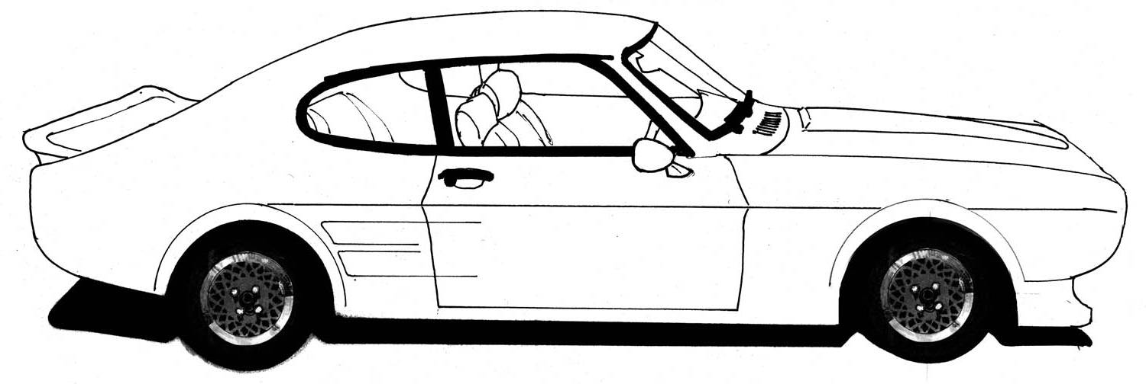
3.

4.

V)Divide the following. Find the quotient and remainder :-

- 2.
2
49
96
3

Quotient: Quotient :
Remainder: Remainder:

3. 4.
5
63
73
6

Quotient: Quotient : :
Remainder: Remainder:
5. 6.
7
79
59
4

Quotient: Remainder : Quotient: Remainder :
7. 8.
68
79
2
6

Quotient: Quotient : :
Remainder: Remainder:

9. 10.
5
83
95
3

Quotient: Quotient : :
Remainder: Remainder:

11. 12.
64
84
6
4

Quotient: Remainder : Quotient: Remainder :
13. 14.
58
69
3
2

Quotient: Quotient : :
Remainder: Remainder:

15. 16.
5
93
93
6

Quotient: Quotient : :
Remainder: Remainder:

17. 18.
84
65
5
4

Quotient: Remainder : Quotient: Remainder :
CHAPTER 10. MONEY
I)Write the amount in words :

- 65.50 =________________________________________________________________


- 65.50 =________________________________________________________________

- 78.25 =________________________________________________________________

- 263 =________________________________________________________________

- 50.65 =________________________________________________________________

- 550 =________________________________________________________________

- 335 =________________________________________________________________

- 45.30 =________________________________________________________________

- 25.50 =________________________________________________________________

II)Write the amount in figures :

- Eighty five rupees and fifty paise : _____________________________________
- Five hundred and forty five rupees : _____________________________________
- Ninety rupees and twenty paise : _____________________________________
- One hundred and fifteen rupees : _____________________________________
- Two hundred rupees : _____________________________________
- Twenty five rupees and ten paise : _____________________________________

III)Find the total amount :

1) | 20p + 20p + 10p =  Ans : __________________________________
2) | 50p + 20p + 30p =  Ans : __________________________________
3) | 25p + 30p + 10p =  Ans : __________________________________
4) | 40p + 10p + 5p =  Ans : __________________________________

IV) Add and write the amount in the figure and words:

1) | - 50 + 10 + 50p =  Ans : __________________________________
2) | - 100 + 50 + 5 =  Ans : __________________________________
3) | - 75 + 25 + 10=  Ans : __________________________________
4) | - 40 + 30=  Ans : __________________________________
5) | 500 + 40=  Ans : __________________________________
6) | - 20 + 5 + 50p =  Ans : __________________________________
7) | - 50 + 20 + 5 =  Ans : __________________________________

V) Add the following :

. P  15 . 10  +30 . 20 | . P  90 . 10  +20 . 10
. P  14 . 80  +24 . 55 | . P  20 . 80  +30 . 10
. P  65 . 70  +30 . 25 | . P  42 . 90  +24 . 30
. P  45 . 75  +13 . 45 | . P  25 . 35  +20 . 45

VI) Word problem on addition of Money :
- Ali bought a pencil for 8 and an eraser for 9. How much money did he spend ?

Ans :_______________________________

- Sunil bought a cricket bat for 334 and a tennis set for 230.75. How much money did he pay?

Ans :______________________________

- Ruby had 400. She got 95 from the grocer. How much money did she have now ?

Ans :______________________________

- Simi bought mangoes for46.50 and bananas for20.50 .How much money did she spend in all?

Ans :______________________________

- Diya has90 and her father gave her50 more. How much money does she have now?

Ans :______________________________

VII) Fill in the blanks : [Division & Money]

- ____________________________________ is repeated subtraction.
- The answer in division is called the ___________________________.
- The sign of division is ____________________________.
- 36 _________= 4.
- 0 divided by any number gives ______________ as answer.
- __________ 6 = 7.
- The symbol for Indian rupees is ________________.
- The money we use comes in the form of ______________ and _________________.
- Coins are made of ______________________.
- ______________ are made of paper.
- 1 rupee = _______________ paise.
- 100 paise = ____________________.
- Two __________ paise coins make 1 rupee.
- Four _____________ paise coins make 1 rupee.
- Five _______________________ paise coins make 1 rupee.
- The study of coins is called .___________________________
[Note : Choose the correct answer and match the following can be asked for the exam]
VIII) Choose the correct answer :
- The sign for division ________________________
[
- Division is repeated ________________________
[
- 48 8________________________
[ ]
- The symbol for Indian rupee is ________________________
[
- 1 rupee = ________________ paise . [100, 200, 300]

