INTERNATIONAL INDIAN SCHOOL, RIYADH
CLASS 1 – ENGLISH
FIRST TERM WORK SHEET 2012-2013

I. Write a composition on “My Best Friend”.

1._______________________________________________________________
_______________________________________________________________
2._______________________________________________________________
_______________________________________________________________
3._______________________________________________________________
_______________________________________________________________
4._______________________________________________________________
_______________________________________________________________
5._______________________________________________________________
II.Match the animal with the type of tail it has:-
1} rabbit a} big
2} horse b} small
3} bird c} striped
4} monkey d} tiny
5} raccoon e}long
III. Tick (√) for the correct sentence and (×) for the wrong sentence:
1} The monkey swings on the tree. [ ]
2} Little Grey Cat does not like his tail. So he wants a new one. [ ]
3} The bird has a big tail. [ ]
4} The cats see a rabbit with a small,white tail. [ ]

IV. Label the different parts of the elephant:
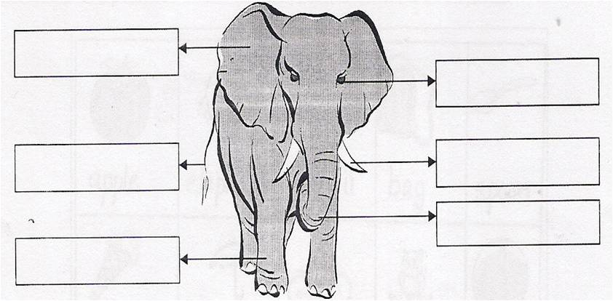
V. Match the animals with the right sounds :

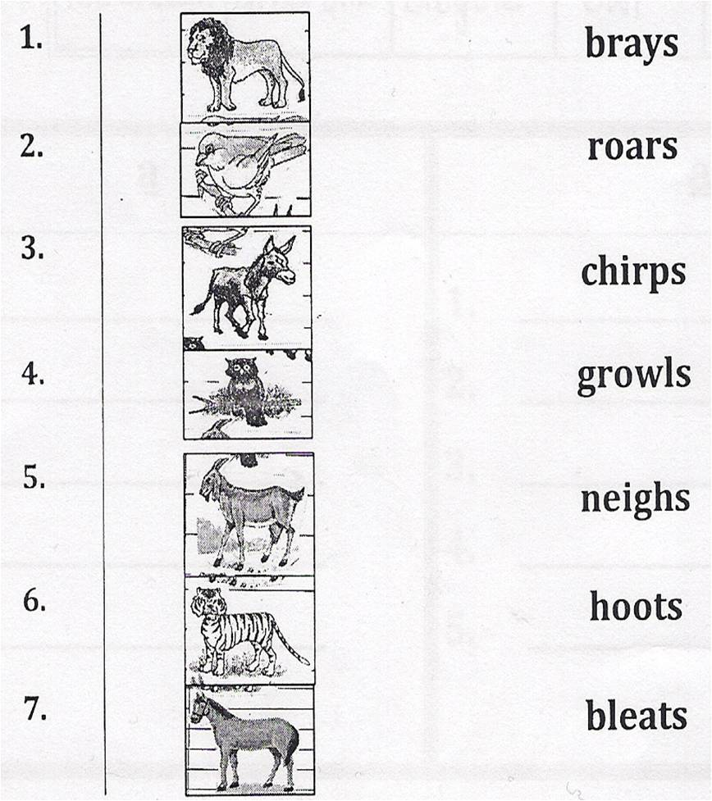
(3)
VI. Write the opposite:-
1} boy × ____________ 6} happy × ___________
2} old × ____________ 7} long × ___________
3} same × ____________ 8} empty × ___________
4} clean × ____________ 9} black × ___________
VII) Complete these sentences:-
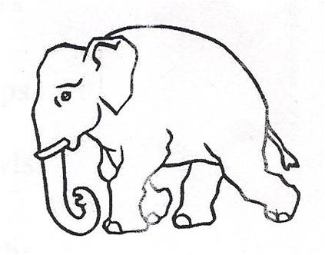
1} Jumbo is an _______________________.
2} He is a ___________________ elephant.
3} He has a ____________ ____________.
4} He also has a ___________________________.
5} fat × ____________ 10} hot × ____________
VIII. Complete the colour words & fill the boxes with the colour:
1} r__d 6} gr__y
2} bl__ __ 7} bl__ck
3} y__ ll__w 8} wh__t__
4} gr__ __n 9} br__wn
5} __r__ng___
X) Use ‘a’ or ‘an’ to complete the sentences with the help of the given words:
IX. Re-arrange these words and write complete sentences:
1} in summer / hot / It / is
Ans: _________________________________________________.
2} She / eating / ice-cream / is / an
Ans: _________________________________________________.
3} mangoes / These / sweet / are
Ans: _________________________________________________.
4} am / I / swimming
Ans: _________________________________________________.
Mango egg apple sandwich bun
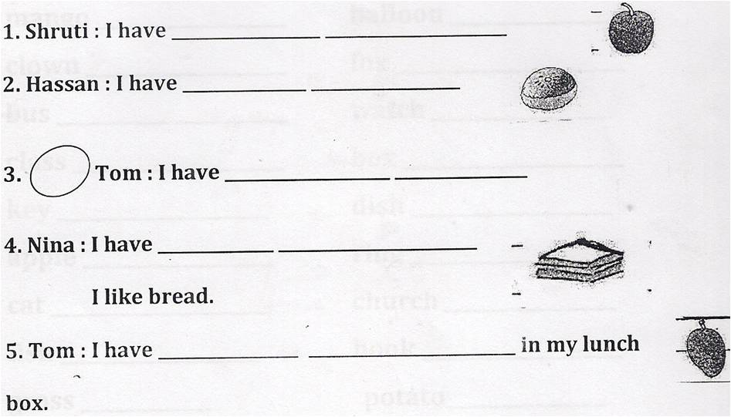
XI. Write the plurals for the folling words:
1} bag __________ 16} fruit __________
2} church _________ 17} bench __________
3} potato __________ 18} mango _________
4} book __________ 20} bottle __________
5} girl __________ 21} torch __________
6} tax __________ 22} cat __________
7} star __________ 23} ring __________
8} key __________ 24} glass __________
9} watch __________
10} boy __________
11} fish __________
12} flower __________
13} fox __________
14} dish __________
15} bear __________
NOTE: Learn more ‘s’ & ‘es’ words only.
XII. Answer the following questions:
1} Where is Zara ?
Ans: ____________________________________________________________
_____________________________________________________________
2} Who has a lovely tail?
Ans: ____________________________________________________________
_____________________________________________________________
3} Where does Jumbo walk ?
Ans: ____________________________________________________________
_____________________________________________________________
4} Why is the little Grey cat sad?
Ans: ____________________________________________________________
_____________________________________________________________

5} Who is Jumbo ?
Ans: ____________________________________________________________
_____________________________________________________________
6} Why is the little girl crying?
Ans: ____________________________________________________________
_____________________________________________________________
7} How does Jumbo help the girl?
Ans: ____________________________________________________________
_____________________________________________________________
8} Where can we play when it is very hot?
Ans: ____________________________________________________________
_____________________________________________________________
9} Why it is hot in summer ?
Ans: ____________________________________________________________
_____________________________________________________________
10} Write three ways to keep your body cool in summer
Ans: ____________________________________________________________
_____________________________________________________________
_____________________________________________________________
XIII. Fill in the blanks:
1} The horse has a ___________ tail.
2} The rabbit has a ___________ tail.
3} Little Grey Cat has ____________ tail.
4} The monkey has a _________ tail.
5} The peacock has a _______________tail.
XIV)Define a Noun or What is a noun?
Ans : ________________________________________________________________
____________________________________________________________________
____________________________________________________________________
Define an Adjective or What is an adjective ?
Ans : ________________________________________________________________
____________________________________________________________________
____________________________________________________________________XV. Underline the nouns in the following sentences:
1} That is my book.
2} The girls are singing.
3} I like to eat burger.
4} The woman is sleeping.
5} His shoes are dirty.
6} A horse runs fast.
7} The boys are fighting.
8} Tom is very tall.
9} We went to the beach.
10} Zara is playing.
11}Honey is sweet.
12}The moon shines at night.
13}The cat is sleeping.
14}My bag is new.
15}I live in Riyadh
16}The elephant has a long trunk.
17}My uncle is in Japan.
18}The boys are playing.
19}My sister has a little puppy.
20}I like to eat mangoes.
21}My mother is a nurse.
22}We have a beautiful house.
{ Practise with different sentences}
XVI). Write ‘a’ or ‘an’for the following words:
1} --------- duck
2} --------- engine
3} ---------- pencil
4} ------------- apple
5} ------------- orange
6} ---------------- aunt
7} -------------- umbrella
8} ---------- table
9} ----------- ice- cream
10} ---------- ear
11}_______Owl
12}_________boy
13} _________can
14}________fish
15}________bag
16}______ engie
17)_________ apple
18)________lamp
19}_______ ant
20} ____________tree
21}__________ear
22}_________book
23} ___________girl
24} ________infant
25}__________doll
26}_________glass
27)________envleope
28) _________fruit
29)_________watch
30_________eye { Practise with different words }
XVII). Complete the sentences using am , is or are:
1} The sun ------------ shining.
2} The boys ---------- playing football.
3} These books _______________ mine
4} Anoop _________________my best friend
5} He _____________ a doctor.
6} It _______________ raining.
7} I_____________doing my work.
8} Arun and Ann __________________readily.
9} The girls _______________ dancing
10} I __________ am seven years old.
11} There __________ many birds flying in the sky.
12} Meena ___________cooking in the kitchen.
13} Children _______________writing a story.
14} These flowers __________very beautiful.
15} Anoop _____________ my best friend.
16} He _________________ a doctor
3} My father ----------- reading a book.
4} She ---------- dancing.
5} We ------------ sitting in the class.
6}He ------------ laughing.
7} It ---------- raining heavily.
8} They ---------- swimming in the river.
9} The fat man ------------ snoring.
10} I ------------ going to Dammam. { Practise with different sentences}
XVIII) Complete the sentences using “There is” or “There are”:
1} ------------ -------------- a boy in the hall.
2} ------------ ------------ many books on the table.
3} ---------- ------------- a monkey on the tree.
4} ----------- ------------- a girl in the picture.
5} ---------- -------------- flowers in the vase.
6} --------- ----------- a cup on the table.
7} ----------- ----------- many boys in the class.
8} ---------- ---------- a pencil in your bag.
9} ---------- ------------- a plate on the kitchen.
10} ------------ -------------- ducks in the water.
11} ______ _____________ trees outside the house.
12} _____________ ___________ a sun in the sky.
13} __________ __________is a man sitting on the chair.
14}___________ ______________ boys playing with a ball.
15}___________ _____________ a bird on the tree.
{ Practise with different sentences}

XIX).Choose the correct nouns from the box and write them in the correct column:
Rita hospital rabbit India bottle man bag teacher ice-cream horse park school book sister monkey

PERSONS PLACES
1} --------------------- 1} --------------------
2} ------------------- 2} --------------------
3} --------------------- 3} --------------------
4} ------------------- 4} --------------------
ANIMAL THINGS
1} --------------------- 1} --------------------
2} ------------------- 2} --------------------
3} --------------------- 3} --------------------
4} ------------------- 4} --------------------
{ Practise with different sentences}
XX). Fill in the blanks with the words given in the box:
hot small wet long pretty new big
fast lovely funny wet loose dry

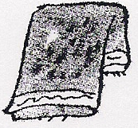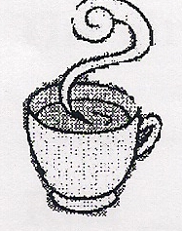
1} __ ______ towel 2}_ _____ milk
3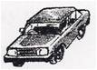_______ car
4}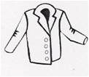______ coat 5}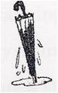____ umbrella
6}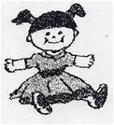_________ doll
7} a 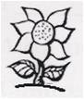_________ flower 8} a 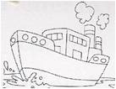_____ ship
9}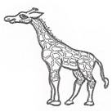_______ legs

10}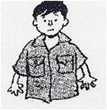_____ shirt 11} a _______ story
12} a 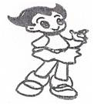_______ girl 13}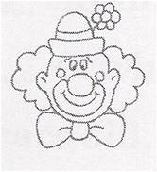________clown

14} 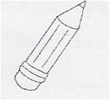_____ pencil

XXI). Look at the picture and describe the things that you see using am, is and are:
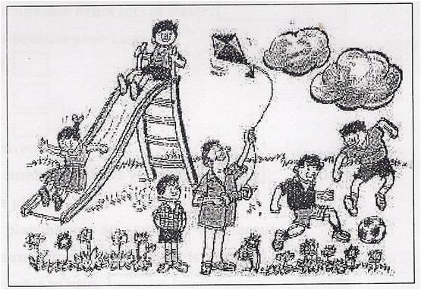
I________ at the park. There ________ flowers in the grass. There ________ a slide. We _______ playing on the slide. A man ________ flying a kite. A little boy ________ watching him. There ________ two clouds in the sky. Two boys ________ playing football.

XXI. Look at these pictures and write the names in the a or an box:
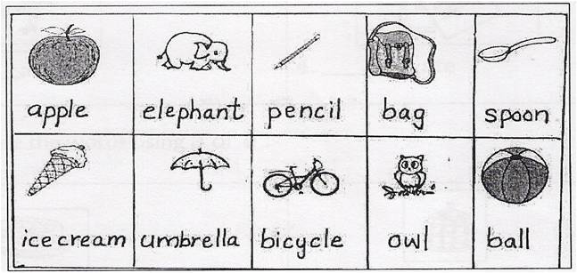

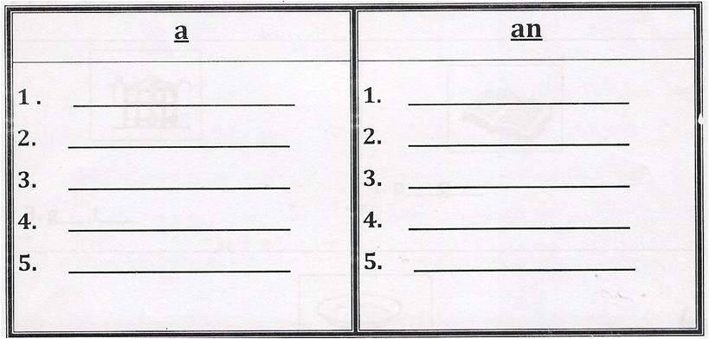

XXII. Name the following:
1} Name two games you play indoors.
Ans 1._______________________
2._______________________
2} Name three ways to keep your body cool in the summer.
Ans 1.__________________________________
2.__________________________________
3.__________________________________
3} Name two games you play outdoors.
Ans 1._______________________
2._______________________
4} Name two fruits you get in the summer.
Ans 1._______________________
2._______________________
XXIII.(A) Complete these-ate words with the help of the pictures:
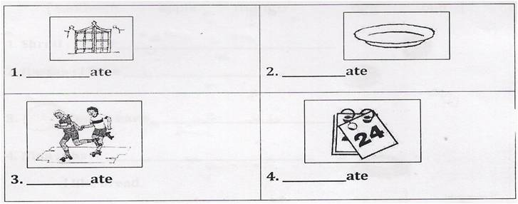
(B) Complete the words using a or e:
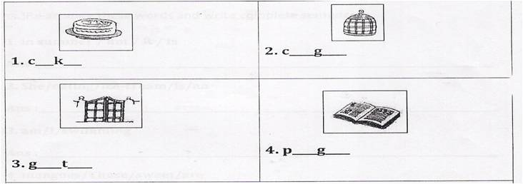
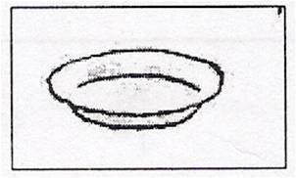
5.pl__t____
XXIV) Choose and Tick {√} the correct answer:
1} All naming words are 2} The word lion is a name of an
Nouns. animal
Adjectives. place

3} Chess is a 4} It is hot in
Outdoor game Summer
Indoor game Winter

5} The bucket has a 6} We get watermelons in
Small hole Winter
Big hole Summer
[NOTE: Practise with different sentences]

