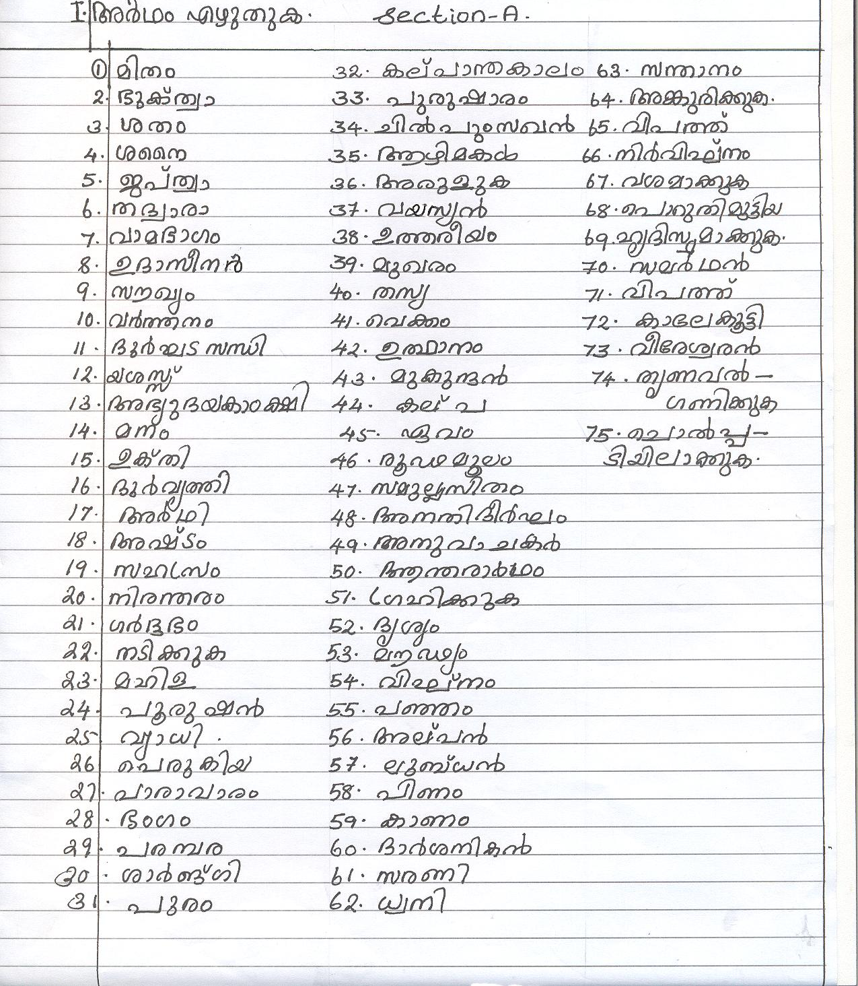
INTERNATIONAL INDIAN SCHOOL, RIYADH
VIII - WORKSHEET SA2 –2012-2013
MALAYALAM


